

S.B. JAIN INSTITUTE OF TECHNOLOGY MANAGEMENT & RESEARCH, NAGPUR

Practical 1 Prelab

Aim: Installation of Linux Operating System.

Name: DARSHAK K. BISANE
USN: CM25D004
Semester / Year: IV/II Academic Session: 2025-26
Date of Performance:
Date of Submission:

- Aim: Installation of Linux Operating System.

Objectives:
  - To identify the hardware and software requirements necessary for installing a Linux operating system.
  - To understand and perform the complete procedure for installing and configuring a Linux distribution.
  - To confirm successful installation and become familiar with basic Linux commands used for initial system setup.

Requirements:
  - A bootable USB drive or DVD containing a Linux distribution such as Ubuntu, Fedora, or Debian.
  - A computer system with minimum specifications including at least 2 GB RAM, 20 GB of available hard disk space, and a supported processor architecture.
  - An active internet connection (optional) for downloading updates and additional packages during installation.
  - A USB bootable creation tool such as Rufus, Balena Etcher, or similar software.
  - Basic understanding of BIOS/UEFI settings to modify the boot order of the system.

**IN THIS PRACTICAL WE’LL BE INSTALLING UBUNTU**

Prerequisite:
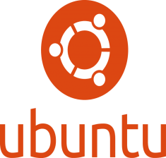
Linux is an open-source operating system widely used for personal, professional, and server environments. Its flexibility, security, and community-driven development make it a popular choice for users. The installation of a Linux OS involves
creating a bootable medium, setting up the system to boot from the medium, and following the installation wizard to partition the disk and configure system settings. Common distributions like Ubuntu, Fedora, and Debian offer user-friendly interfaces for easy installation. The process may include creating swap space, selecting a file system like ext4, and setting up user accounts. Post-installation
tasks involve updating the system, installing necessary drivers, and customizing the environment. Understanding the installation process ensures better control over system performance and resource allocation, making Linux a powerful tool for both beginners and advanced users.

Steps to Make a Pendrive Bootable Using Rufus:

- Download and Open Rufus: Download Rufus from its official website, install it, and launch the application.
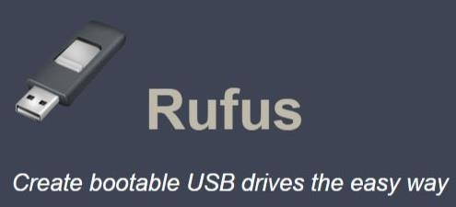
- Insert Pendrive and Select ISO: Connect the USB pendrive to your system. In Rufus, select your pendrive under "Device" and click "SELECT" to choose the Linux ISO file.
- Set Partition Scheme and File System: Choose "GPT" for UEFI or "MBR" for BIOS under "Partition scheme," and ensure the file system is set to "FAT32."
- Start the Process: Click "START," confirm the warning about data deletion, and wait for Rufus to create the bootable USB. Once done, eject the pendrive safely.

Theory:
An operating system (OS) is a fundamental system software that manages computer hardware and provides a platform for running application programs. It serves as a bridge between the user and the hardware, ensuring efficient and organized system operation.

Functions of an Operating System:

- User Interface Management: Provides a user-friendly interface (GUI or CLI) that allows users to interact easily with the computer system.
- Resource Allocation: Distributes system resources like CPU time, memory, and devices fairly among running programs.
- Error Detection and Handling: Identifies system errors, hardware faults, and software failures to maintain stable system operation.
- Networking Management: Enables communication between computers by managing network connections, data transfer, and protocols.
- Power Management: Controls power usage of the system to improve energy efficiency and extend battery life.

Types of Operating Systems:

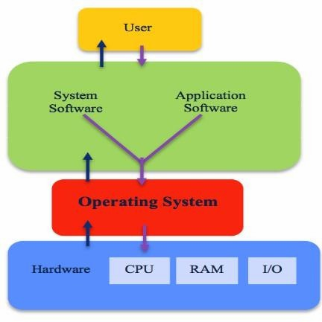
- Batch OS: Executes tasks in batches without direct user interaction.
- Time-Sharing OS: Allows multiple users to share system resources simultaneously.
- Distributed OS: Manages a group of independent computers and makes them appear as a single system.
- Real-Time OS: Designed for time-critical tasks where responses are needed within strict deadlines.
- Mobile OS: Specialized for mobile devices, such as Android and iOS.

Operating systems such as Windows, Linux, and macOS are commonly used on different devices, each designed to meet particular user demands. Linux is widely appreciated for its open-source framework and high level of customization, whereas Windows is popular for its ease of use and broad application support in both personal and professional environments.

In summery, an operating system serves as the core component of a computer system, managing hardware resources, enabling user interaction, and maintaining overall system stability. As technology advances, operating systems continue to develop, addressing new challenges and accommodating the changing needs of users.

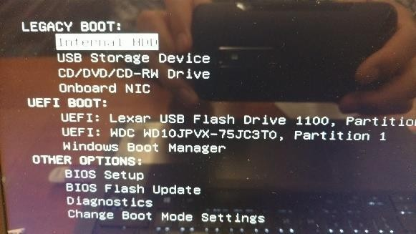

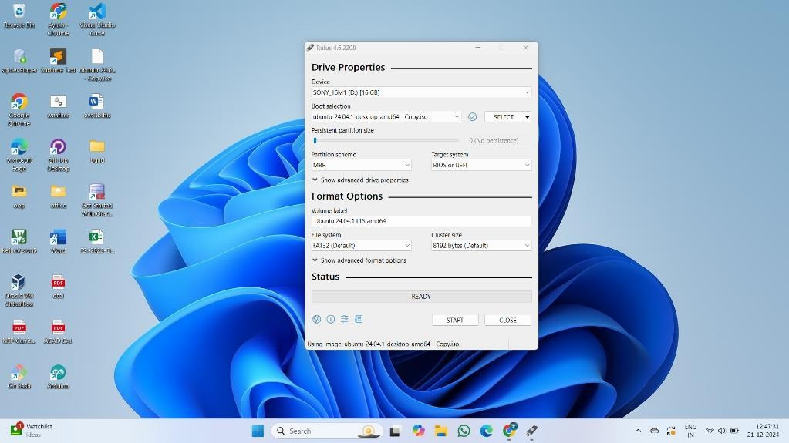

Steps to Install Linux Operating System:
  - Prepare Bootable Media: Use a tool like Rufus to create a bootable USB drive or DVD with the Linux distribution ISO.

  - Configure BIOS/UEFI Settings: Restart your computer and access the BIOS/UEFI settings (usually by pressing a key like F2, F10, or DEL during boot). Set the boot priority to USB or DVD.

  - Boot from Media: Insert the bootable USB or DVD and restart the computer. The system will boot into the Linux installer.
  - Choose Installation Option: Select "Install Linux" or a similar option from the menu. Some distributions may allow you to try the OS before installation.
  - Partition the Disk:
    - Select the partition scheme (automatic or manual).
    - Create required partitions (e.g., root /, swap, and optionally /home).
  - Set Up User Details: Enter your username, password, and system name.
  - Select Time Zone: Choose your location to configure the correct time and date settings.
  - Begin Installation: Review the settings and click "Install." The process will take a few minutes to complete.


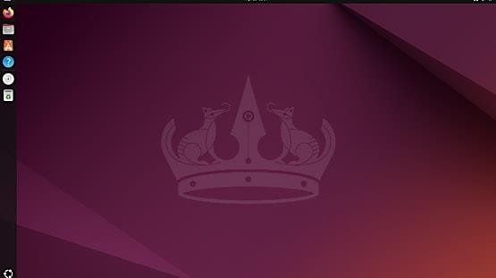

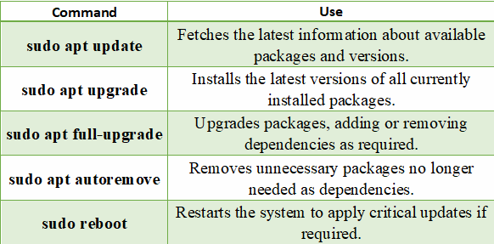

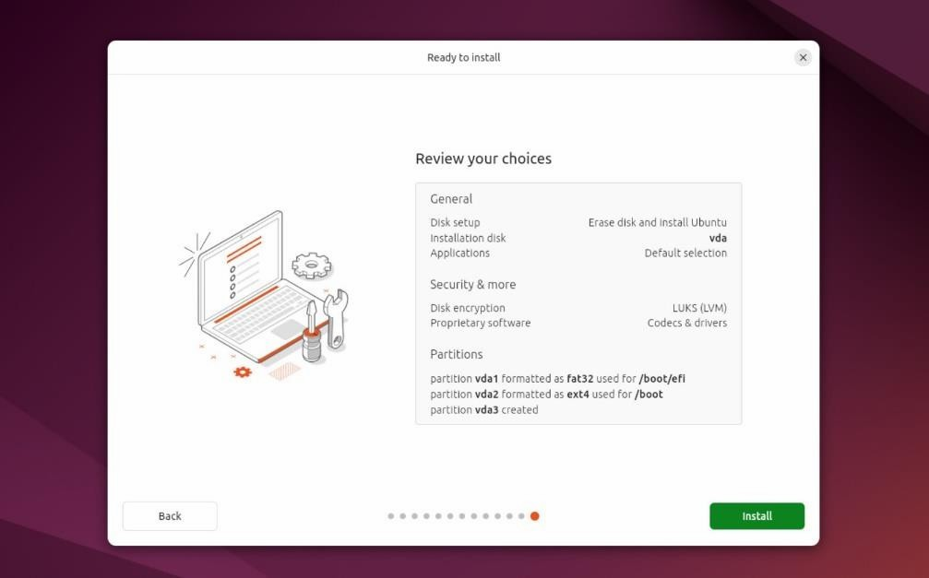

  - Remove Bootable Media: Once installation is finished, remove the USB or DVD when prompted and restart the system.

  - Post-Installation Configuration: Log in to your new Linux system, update packages, and install additional software if needed.

Commands to update:

- Conclusion: The installation of the Linux operating system provides a hands-on understanding of system setup and configuration. It enables efficient utilization of resources and customization to suit user needs. Mastering this process builds a solid foundation for exploring advanced system administration tasks.

Discussion Questions:
  - Q: What is an operating system, and why is it important?
  - Q: What is the purpose of creating a bootable USB, and how is it done?
  - Q: Can you explain the difference between apt update and apt upgrade in Ubuntu?
  - Q: Why is partitioning necessary during OS installation, and what are the common partitions used?
  - Q: What steps should you follow after successfully installing a Linux OS?

References:

https://ubuntu.com/tutorials/install-ubuntu-desktop#1-overview https://youtu.be/wjbbl0TTMeo?si=32l6h8VbcmU-euD_ https://answers.microsoft.com/
https://rufus.ie/en/

Date: / /2026 Signature
Course Coordinator B.Tech CSE(AIML) Sem: 4 / 2025-26

